**AND Gate (2-Inputs)**

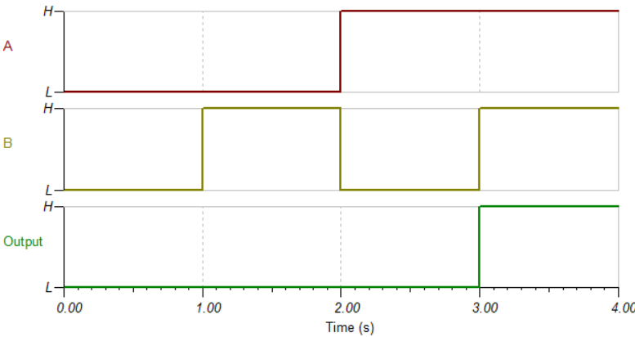

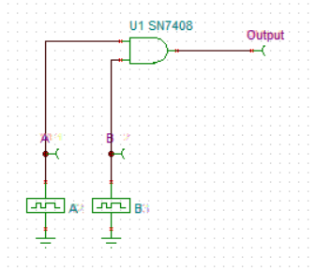

**Truth Table**

|  |  |  |  |
| --- | --- | --- | --- |
| **S.No.** | **A**  **(Input-1)** | **B**  **(Input-2)** | **Output** |
| **0.** | 0 | 0 | 0 |
| **1.** | 0 | 1 | 0 |
| **2.** | 1 | 0 | 0 |
| **3.** | 1 | 1 | 1 |

**OR Gate (2-Inputs)**

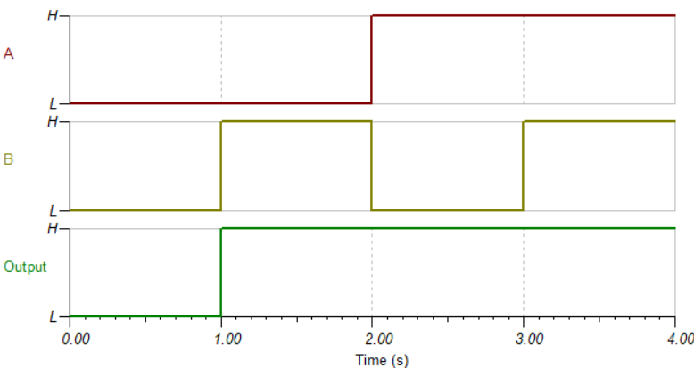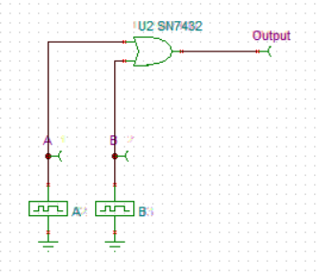

**Truth Table**

|  |  |  |  |
| --- | --- | --- | --- |
| **S.No.** | **A**  **(Input-1)** | **B**  **(Input-2)** | **Output** |
| **0.** | 0 | 0 | 0 |
| **1.** | 0 | 1 | 1 |
| **2.** | 1 | 0 | 1 |
| **3.** | 1 | 1 | 1 |

**NAND Gate (2-Inputs)**

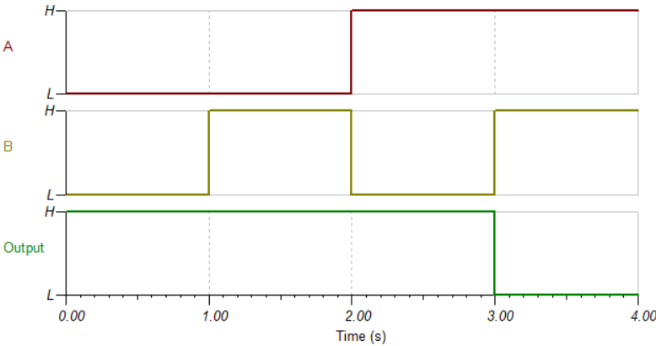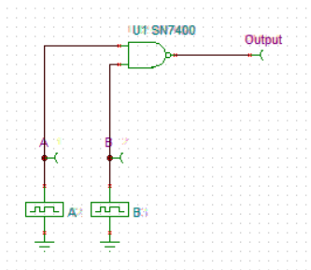

**Truth Table**

|  |  |  |  |
| --- | --- | --- | --- |
| **S.No.** | **A**  **(Input-1)** | **B**  **(Input-2)** | **Output** |
| **0.** | 0 | 0 | 1 |
| **1.** | 0 | 1 | 1 |
| **2.** | 1 | 0 | 1 |
| **3.** | 1 | 1 | 0 |

**NOR Gate (2-Inputs)**

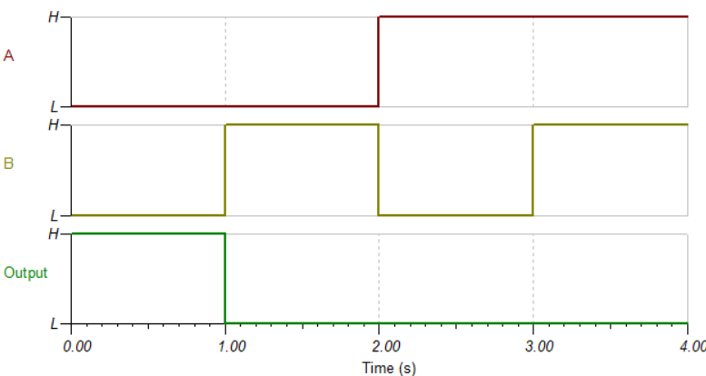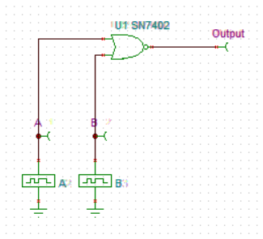

**Truth Table**

|  |  |  |  |
| --- | --- | --- | --- |
| **S.No.** | **A**  **(Input-1)** | **B**  **(Input-2)** | **Output** |
| **0.** | 0 | 0 | 1 |
| **1.** | 0 | 1 | 0 |
| **2.** | 1 | 0 | 0 |
| **3.** | 1 | 1 | 0 |

**EX-OR Gate (2-Inputs)**

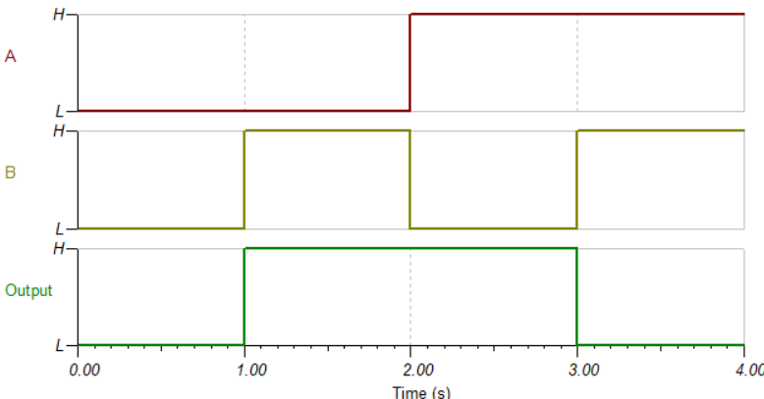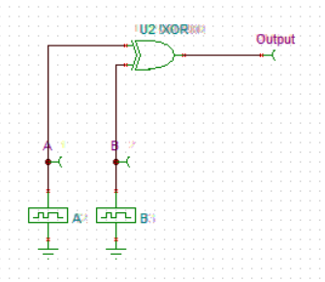

**Truth Table**

|  |  |  |  |
| --- | --- | --- | --- |
| **S.No.** | **A**  **(Input-1)** | **B**  **(Input-2)** | **Output** |
| **0.** | 0 | 0 | 0 |
| **1.** | 0 | 1 | 1 |
| **2.** | 1 | 0 | 1 |
| **3.** | 1 | 1 | 0 |

**AND Gate (3-Inputs)**

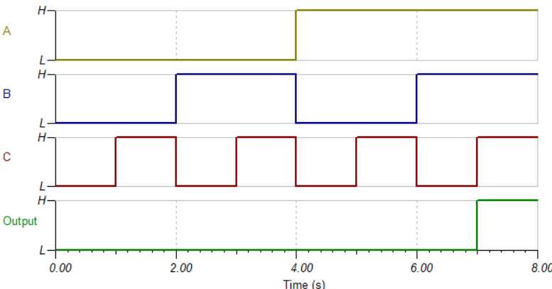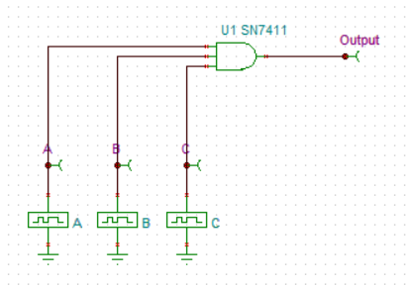

**Truth Table**

|  |  |  |  |  |
| --- | --- | --- | --- | --- |
| **S.No.** | **A**  **(Input-1)** | **B**  **(Input-2)** | **C**  **(Input-3)** | **Output** |
| **0.** | 0 | 0 | 0 | 0 |
| **1.** | 0 | 0 | 1 | 0 |
| **2.** | 0 | 1 | 0 | 0 |
| **3.** | 0 | 1 | 1 | 0 |
| **4.** | 1 | 0 | 0 | 0 |
| **5.** | 1 | 0 | 1 | 0 |
| **6.** | 1 | 1 | 0 | 0 |
| **7.** | 1 | 1 | 1 | 1 |

**OR Gate (3-Inputs)**

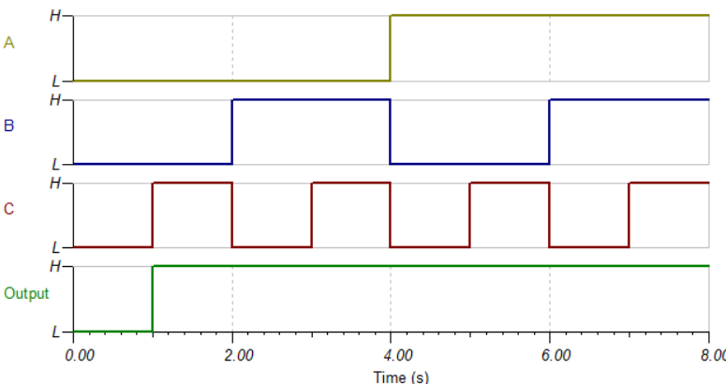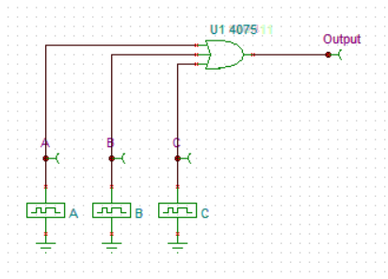

**Truth Table**

|  |  |  |  |  |
| --- | --- | --- | --- | --- |
| **S.No.** | **A**  **(Input-1)** | **B**  **(Input-2)** | **C**  **(Input-3)** | **Output** |
| **0.** | 0 | 0 | 0 | 0 |
| **1.** | 0 | 0 | 1 | 1 |
| **2.** | 0 | 1 | 0 | 1 |
| **3.** | 0 | 1 | 1 | 1 |
| **4.** | 1 | 0 | 0 | 1 |
| **5.** | 1 | 0 | 1 | 1 |
| **6.** | 1 | 1 | 0 | 1 |
| **7.** | 1 | 1 | 1 | 1 |

**NAND Gate (3-Inputs)**

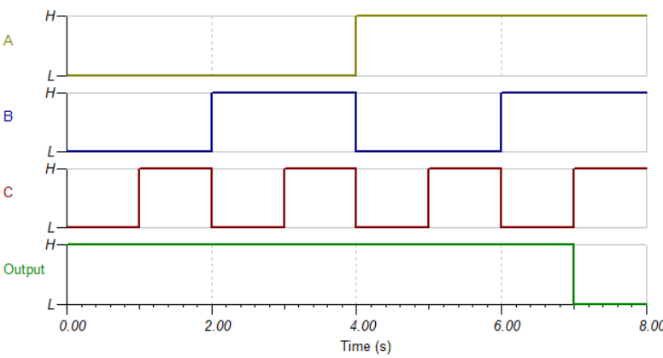

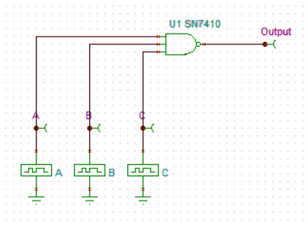

**Truth Table**

|  |  |  |  |  |
| --- | --- | --- | --- | --- |
| **S.No.** | **A**  **(Input-1)** | **B**  **(Input-2)** | **C**  **(Input-3)** | **Output** |
| **0.** | 0 | 0 | 0 | 1 |
| **1.** | 0 | 0 | 1 | 1 |
| **2.** | 0 | 1 | 0 | 1 |
| **3.** | 0 | 1 | 1 | 1 |
| **4.** | 1 | 0 | 0 | 1 |
| **5.** | 1 | 0 | 1 | 1 |
| **6.** | 1 | 1 | 0 | 1 |
| **7.** | 1 | 1 | 1 | 0 |

**NOR Gate (3-Inputs)**

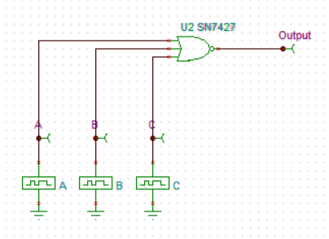

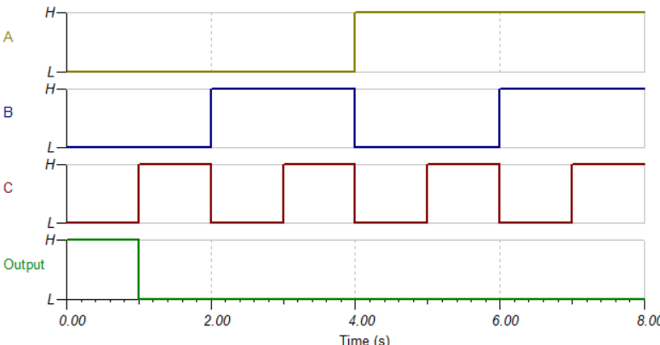

**Truth Table**

|  |  |  |  |  |
| --- | --- | --- | --- | --- |
| **S.No.** | **A**  **(Input-1)** | **B**  **(Input-2)** | **C**  **(Input-3)** | **Output** |
| **0.** | 0 | 0 | 0 | 1 |
| **1.** | 0 | 0 | 1 | 0 |
| **2.** | 0 | 1 | 0 | 0 |
| **3.** | 0 | 1 | 1 | 0 |
| **4.** | 1 | 0 | 0 | 0 |
| **5.** | 1 | 0 | 1 | 0 |
| **6.** | 1 | 1 | 0 | 0 |
| **7.** | 1 | 1 | 1 | 0 |

**AND Gate (4-Inputs)**

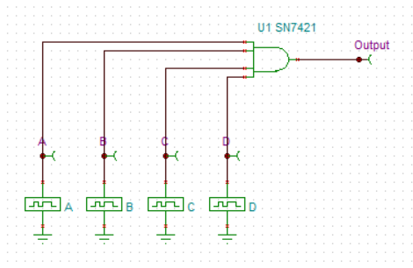

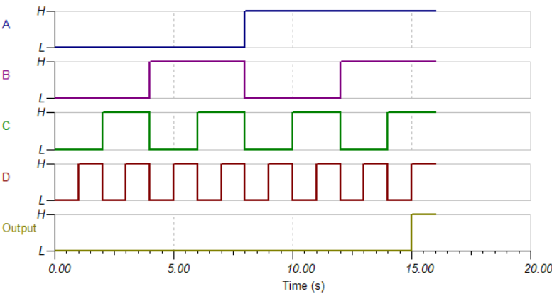

**Truth Table**

|  |  |  |  |  |  |
| --- | --- | --- | --- | --- | --- |
| **S.No.** | **A**  **(Input-1)** | **B**  **(Input-2)** | **C**  **(Input-3)** | **D**  **(Input-4)** | **Output** |
| **0.** | 0 | 0 | 0 | 0 | 0 |
| **1.** | 0 | 0 | 0 | 1 | 0 |
| **2.** | 0 | 0 | 1 | 0 | 0 |
| **3.** | 0 | 0 | 1 | 1 | 0 |
| **4.** | 0 | 1 | 0 | 0 | 0 |
| **5.** | 0 | 1 | 0 | 1 | 0 |
| **6.** | 0 | 1 | 1 | 0 | 0 |
| **7.** | 0 | 1 | 1 | 1 | 0 |
| **8.** | 1 | 0 | 0 | 0 | 0 |
| **9.** | 1 | 0 | 0 | 1 | 0 |
| **10.** | 1 | 0 | 1 | 0 | 0 |
| **11.** | 1 | 0 | 1 | 1 | 0 |
| **12.** | 1 | 1 | 0 | 0 | 0 |
| **13.** | 1 | 1 | 0 | 1 | 0 |
| **14.** | 1 | 1 | 1 | 0 | 0 |
| **15.** | 1 | 1 | 1 | 1 | 1 |

**OR Gate (4-Inputs)**

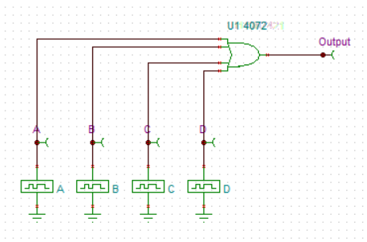

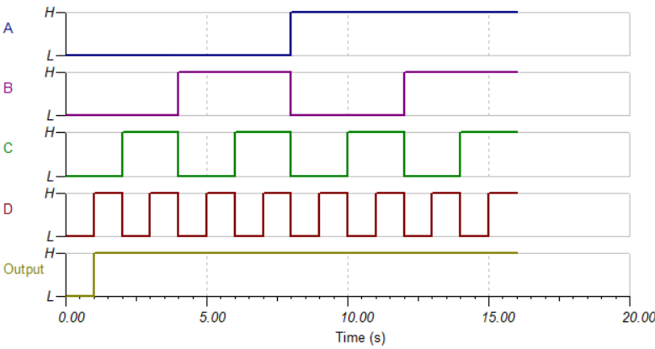

**Truth Table**

|  |  |  |  |  |  |
| --- | --- | --- | --- | --- | --- |
| **S.No.** | **A**  **(Input-1)** | **B**  **(Input-2)** | **C**  **(Input-3)** | **D**  **(Input-4)** | **Output** |
| **0.** | 0 | 0 | 0 | 0 | 0 |
| **1.** | 0 | 0 | 0 | 1 | 1 |
| **2.** | 0 | 0 | 1 | 0 | 1 |
| **3.** | 0 | 0 | 1 | 1 | 1 |
| **4.** | 0 | 1 | 0 | 0 | 1 |
| **5.** | 0 | 1 | 0 | 1 | 1 |
| **6.** | 0 | 1 | 1 | 0 | 1 |
| **7.** | 0 | 1 | 1 | 1 | 1 |
| **8.** | 1 | 0 | 0 | 0 | 1 |
| **9.** | 1 | 0 | 0 | 1 | 1 |
| **10.** | 1 | 0 | 1 | 0 | 1 |
| **11.** | 1 | 0 | 1 | 1 | 1 |
| **12.** | 1 | 1 | 0 | 0 | 1 |
| **13.** | 1 | 1 | 0 | 1 | 1 |
| **14.** | 1 | 1 | 1 | 0 | 1 |
| **15.** | 1 | 1 | 1 | 1 | 1 |

**NAND Gate (4-Inputs)**

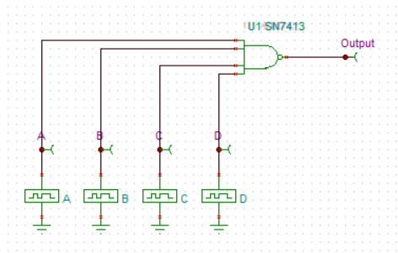

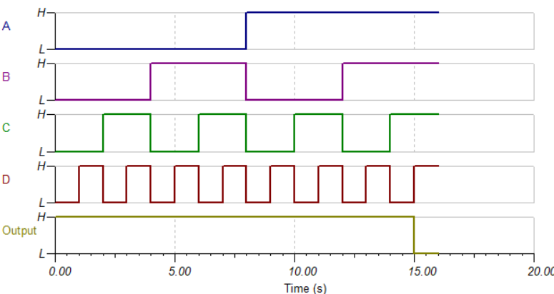

**Truth Table**

|  |  |  |  |  |  |
| --- | --- | --- | --- | --- | --- |
| **S.No.** | **A**  **(Input-1)** | **B**  **(Input-2)** | **C**  **(Input-3)** | **D**  **(Input-4)** | **Output** |
| **0.** | 0 | 0 | 0 | 0 | 1 |
| **1.** | 0 | 0 | 0 | 1 | 1 |
| **2.** | 0 | 0 | 1 | 0 | 1 |
| **3.** | 0 | 0 | 1 | 1 | 1 |
| **4.** | 0 | 1 | 0 | 0 | 1 |
| **5.** | 0 | 1 | 0 | 1 | 1 |
| **6.** | 0 | 1 | 1 | 0 | 1 |
| **7.** | 0 | 1 | 1 | 1 | 1 |
| **8.** | 1 | 0 | 0 | 0 | 1 |
| **9.** | 1 | 0 | 0 | 1 | 1 |
| **10.** | 1 | 0 | 1 | 0 | 1 |
| **11.** | 1 | 0 | 1 | 1 | 1 |
| **12.** | 1 | 1 | 0 | 0 | 1 |
| **13.** | 1 | 1 | 0 | 1 | 1 |
| **14.** | 1 | 1 | 1 | 0 | 1 |
| **15.** | 1 | 1 | 1 | 1 | 0 |

**NOR Gate (4-Inputs)**

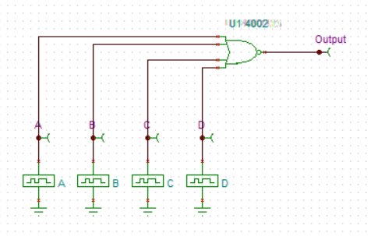

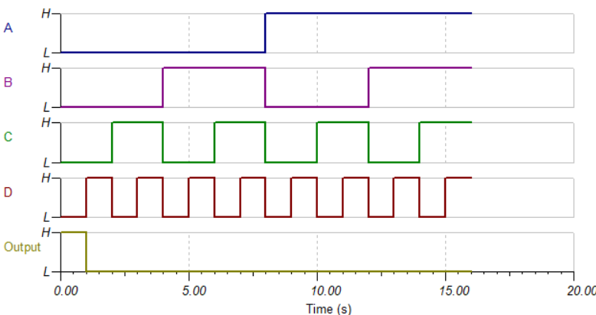

**Truth Table**

|  |  |  |  |  |  |
| --- | --- | --- | --- | --- | --- |
| **S.No.** | **A**  **(Input-1)** | **B**  **(Input-2)** | **C**  **(Input-3)** | **D**  **(Input-4)** | **Output** |
| **0.** | 0 | 0 | 0 | 0 | 1 |
| **1.** | 0 | 0 | 0 | 1 | 0 |
| **2.** | 0 | 0 | 1 | 0 | 0 |
| **3.** | 0 | 0 | 1 | 1 | 0 |
| **4.** | 0 | 1 | 0 | 0 | 0 |
| **5.** | 0 | 1 | 0 | 1 | 0 |
| **6.** | 0 | 1 | 1 | 0 | 0 |
| **7.** | 0 | 1 | 1 | 1 | 0 |
| **8.** | 1 | 0 | 0 | 0 | 0 |
| **9.** | 1 | 0 | 0 | 1 | 0 |
| **10.** | 1 | 0 | 1 | 0 | 0 |
| **11.** | 1 | 0 | 1 | 1 | 0 |
| **12.** | 1 | 1 | 0 | 0 | 0 |
| **13.** | 1 | 1 | 0 | 1 | 0 |
| **14.** | 1 | 1 | 1 | 0 | 0 |
| **15.** | 1 | 1 | 1 | 1 | 0 |

**BUFFER(1-Pin)**

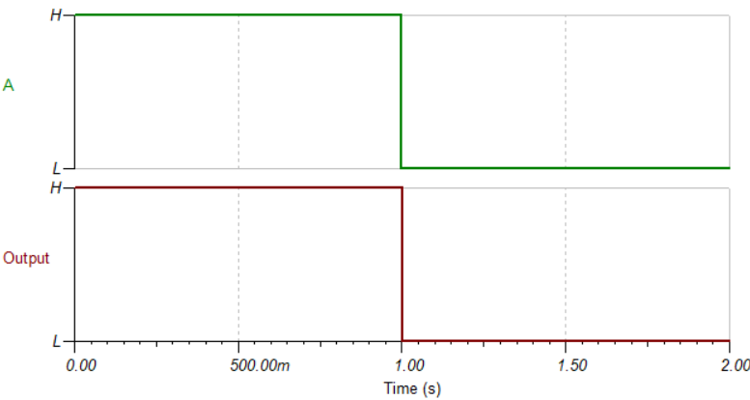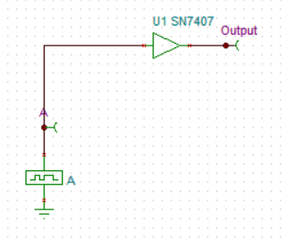

**Truth Table**

|  |  |  |
| --- | --- | --- |
| **S.No.** | **A**  **(Input-1)** | **Output** |
| **0.** | 1 | 1 |
| **1.** | 0 | 0 |

**INVERTER(1-Pin)**

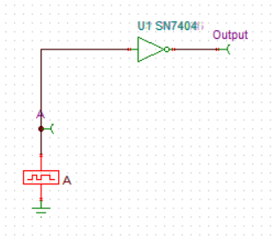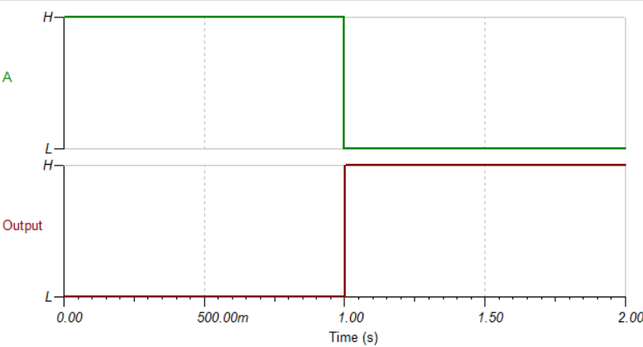

**Truth Table**

|  |  |  |
| --- | --- | --- |
| **S.No.** | **A**  **(Input-1)** | **Output** |
| **0.** | 1 | 0 |
| **1.** | 0 | 1 |